

Lake McConaughy State Recreation Area

To apply, visit [http://outdoornebraska.gov/workinapark/](https://gcc02.safelinks.protection.outlook.com/?url=http%3A%2F%2Foutdoornebraska.gov%2Fworkinapark%2F&data=02%7C01%7Cleesa.ricci%40nebraska.gov%7C76dc10a7f51146fea98c08d7e3097eaf%7C043207dfe6894bf6902001038f11f0b1%7C0%7C0%7C637227502222945034&sdata=L8DxbXFE7EHWuW2%2B%2FKqKBbM5T2OFFPQIas813CGZ4R4%3D&reserved=0)

* **Job Title**: Temporary Park Worker I
* **Location**: *All Cities, NE (specify Lake McConaughy SRA)
* **Job #**: R43011 Temp. Park Worker I, R43012 Temp Park Worker II
* **Pay:** $12.00/$14.00 per hour

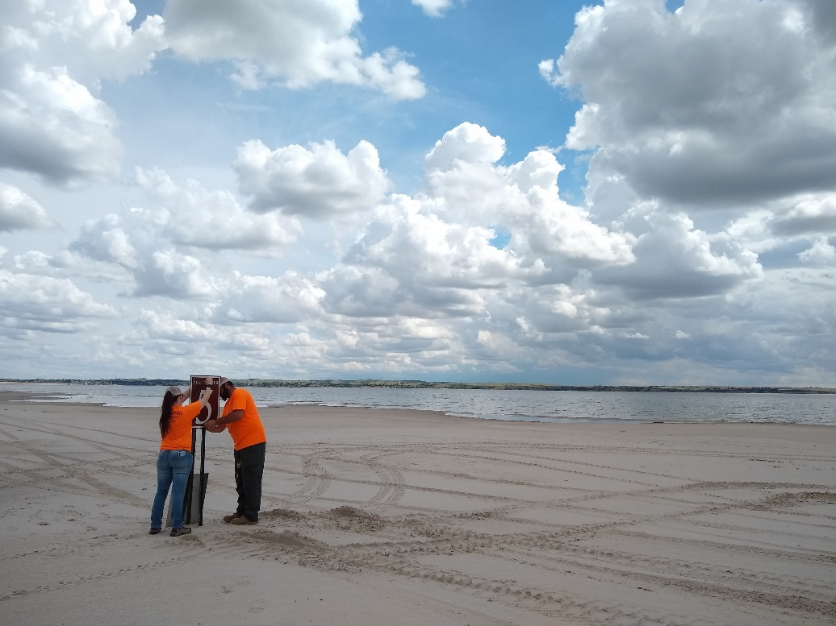

**Maintenance Team Schedules:**

Tuesday to Saturday – 7:00am to 3:30pm

Thursday to Monday – 7:00am to 3:30pm

**Mowing Team Schedules:**

Monday to Thursday – 6:30am to 5pm

**Gatehouse Attendant:**

Sunday to Tuesday – 8:00am to 8:00pm

Wednesday to Saturday – 8:00am to 5pm

Wednesday to Saturday – 2pm – 11pm

**Fee Compliance:**

Tuesday to Saturday – 9:00am to 5:300pm

**Visitor Center:**

Wednesday - Sunday – 1:00pm to 9:00pm

Friday – Tuesday – 1:00pm to 9:00 pm

For more information, call the Lake McConaughy Visitor Center at 308-284-8800

Nebraska Game and Parks Commission is an equal opportunity employer. The State of Nebraska complies with Nebraska’s Veteran’s Preference Laws. Must be 16 years or older to apply.